

Rosslare Harbour/Kilrane

Newsletter

March 2025

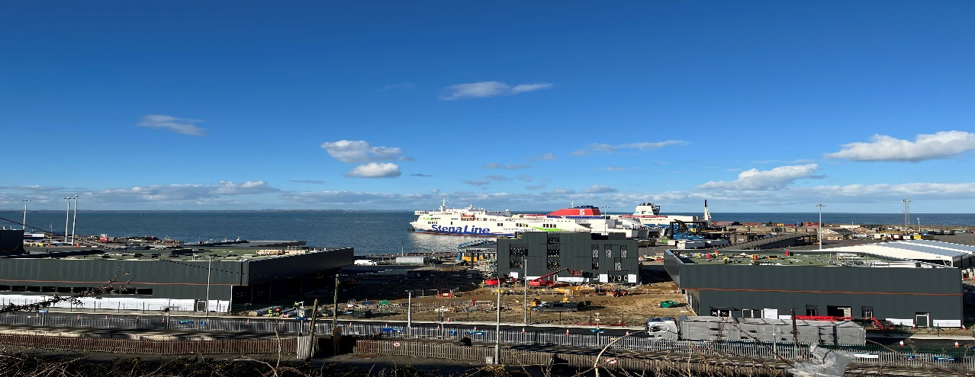*Rosslare Harbour Development Board*

*Rosslare Harbour Development Board*

Rosslare Harbour Development Board moved into

the Community and Enterprise Hub new premises situated on St Martin’s Road on Monday 10th February 2025. The new premises comprising offices and community hub will be a great addition to the area. Offices can be rented on an hourly, daily, weekly, monthly or yearly basis. The community hub can also be hired on an hourly or daily basis. We have already received bookings for a number of different activities. For further information please contact the Resource centre at 087-3579025 or email [rhkcrc@gmail.com](mailto:rhkcrc@gmail.com).

The new Medical Centre will open in the next couple of weeks.

The Penny bank for 2025 is open for collection on Saturday between 11.00am and 12noon at the Resource Centre.

Rosslare Harbour Development Board are delighted to see the works expanding facilities at Rosslare Europort progressing so well.

*Rosslare Harbour Maritime Heritage Centre*

THE VILLAGE THAT DISAPPEARED

Rosslare Fort was built at the then narrow entrance to Wexford Harbour in the late 1500s. It was in the hands of the Confederates in the 1640s. Wexford, from where

they attacked English merchant ships, was their chief naval base. The town and the Fort suffered badly in 1649 when Cromwell exacted his revenge on the population.

The Fort later became a customs post and a village of 40-50 houses grew up around it. In fierce storms during the winter of 1924-1925 the entire settlement was reclaimed by the sea.

(Text courtesy Wexford Free Press)

An exhibition to mark the 100th anniversary of the demise of Rosslare Fort, is currently running at the Rosslare Harbour Maritime Heritage Centre.

**The museum is open every Saturday from 12noon until 4pm. Other times by appointment.**

ALL WELCOME

*Mass Times*

**Saint Patrick Church Rosslare Harbour**

Monday, Tuesday, Wednesday, and Friday **09.30am**

Saturday Vigil **7.00pm,** Sunday **10.30am**

**Saint Ruan Church Kilrane** **Sunday 08.30am.**

**Eucharistic Adoration**

**Saint Ruan Church Kilrane –**Monday**10.00am – 1.00pm**

**Saint Patrick Church Rosslare Harbour**

Wednesday**10am – 1.00pm,** Friday**2.30pm – 4.30pm**

Sunday**2.30pm – 4.30pm.**

*Forever Fit Wexford*

Dance50+ Health and Fitness classes.

Every Wednesday in Kilrane Community Centre,

At 11.00am. Beginners /all levels welcome.

Call for details or to book your place

Contact: Amanda Burke 087 9713339

*KIlrane /Rosslare Harbour Tops*

Community Bingo every Sunday at 8pm in Railway Social Club.

Fun night out in aid of Community Groups

*Kilrane/ Rosslare Harbour Men’s Shed*

The purpose of the Men’s Shed is to provide a place and an opportunity for men to come together to provide support for one another in a friendly atmosphere.

We have two regular meeting days:

Tuesday morning from 10.30am is dedicated to project work, making items for sale, and working on projects for the community.

Thursday morning from 10.30am is mainly a non- working social morning. We meet for a cuppa and a chat.

All men are welcome to join us on these mornings or just to come along and see if it is for them, no obligation to join.

If any of the above is of interest, please feel free to contact us on Facebook.

KRH – Kilrane/Rosslare Harbour Men’s Shed,

or email: kilranerosslareharbourmenshed@gmail.com

Our Shed is located at the Watertower, Saint Brendan’s Estate, Rosslare Harbour Y35 E6X3

*Rosslare Harbour/Kilrane Environment Group*

In preparation for the spring/summer season the cliff top walk is nearly complete. Improvements, due to start in March, to the Outdoor Recreational area next to the playground will give access to all to our

beautiful sea view.

The continued maintenance work on the Secret Garden, Memorial Park and surrounding paths by the local Environment group of volunteers and Community Employment workers is paying off as a display of beautiful flowers are starting to appear for spring. Enjoy a walk and admire the beauty within the Rosslare Harbour / Kilrane Village.

The new composting facility with the support of the Environmental section of Wexford County Council and our Biodiversity Officer, Betty, will be open soon.

The Environment Group are delighted the use of the Apparatus House helped support all the peaceful protestors involved in the 463 days to Save Our Nursing Home, well done to all.

The Rosslare Harbour/ Kilrane Environmental Group would like to thank all supporters and volunteers and welcome new volunteers.

Join us on a Saturday morning from 9.30 am in the memorial park or for a cup of tea at 11.15ish to see how you can support or help.

*The Rosslare Harbour/Kilrane Women’s Shed*

The Women’s shed has returned following the Christmas break with some key activities having taken place since January.  Many thanks to Kata from Mavis Nests who demonstrated soap making, Karen from Ways2Wellness for essential oils demo, Kathleen K, RGN & Menopause Workplace Awareness Trainer who gave a talk on the menopause and our own member Kathleen who gave a wonderful Mexican food demonstration. Thanks to Jackie for our two craft evenings on decoupage. We continue to provide photography classes every Wednesday morning, Tai Chi on Tuesday evenings and line dancing on Friday nights. Our monthly walking, knitting & crochet, gardening and book club also continue - all new members welcome. Keep an eye out for all our upcoming events via our Social Media platforms - Facebook and Instagram and via posters in local businesses.

*Kilrane Rosslare Harbour ICA*

The Guild meet the first Wednesday of each month in the Community Centre, Kilrane at 7.30pm  
We have many different interests within the Guild, cycling, walking, gardening, bowling, palates, swimming,  singing, drama & the usual crafts, oh! not forgetting the card school!!   We compete within Wexford Federation in a variety of competitions and enjoy meeting up with other guilds in our County.

Our garden within the community garden will get a tidy-up as soon as the weather and soil improves.  
We get involved with local events and support our community as best we can. Daffodil day is 28th March this year and many members volunteer on the day to help with collecting donations. We are a group of friends who support one another, love to gather for the cup of tea and a chat and along the way we have lots of laughs and lots of fun.

So whether you're new to the area or living here for years, you'll be more than welcome to come along any 1st Wednesday of the month and see what we are about

*RNLI*

FISH SUPPER 2025.

The committee would like to thank everyone who came along and supported our annual fish supper in the Coast Hotel. A great night was had by all. we would like to thank all our sponsors, Murphy's Supervalu, Pettits supervalu, Saltees, Fish and Kingfisher Fresh LTD for the fish, Atlantis seafood, Eammon Black / Mary Barry’s for the fish pie, Steve Yarr for filleting all the fish, the Coast Hotel and the head chef Mario, Shay Russsell Andrew Berry and our local Sea Shanty group for the entertainment. Thanks to everyone who donated prizes and Davy Rea who donated a lovely framed picture of the lifeboat.

After our AGM on Tuesday 25 Feb the new committee for 2025 is as follows.

Chairperson:              Trish Kavanagh

Vice Chairperson:       Alan Murphy

Secretary:                  James Sheil

Assistant Secretary:  Clare O Rourke

Treasurer:                  Des Murphy

Pro:                            Tommy Carroll

Box Secretary:           Bernie Mullen

Souvenir Secretary    Breda Houghton

Committee: Maire Hope, Trish Carroll, Elaine Pierce, Kim McCusker, Patricia Molloy, Margaret Cullen and Louise Hewitt.

Details of 2025 fundraising events to follow.

Thanks again for all your support in 2024.

*Active Retirement Association*

Active Retirement Association – Kilrane/Rosslare Harbour, the following activities are planned to take place in March 2025: Garden Café - Shrove Tuesday,

4th March at 10.30am – a selection of pancakes, and tea or coffee price, €9.50 per person payable on the day.

Celebrating St Patricks Day, Monday 17th March in Culleton’s of Kilrane, 2 Course Lunch with tea or coffee at 1.00pm. Price €20.00 for members and €25.00 for Non Members payment in advance at weekly Coffee Mornings in the Garden Café.

The weekly coffee mornings in the Garden Café take place every Tuesday at 10.30 am. All are welcome to participate and share news about upcoming events.

General Meeting for ARA Members

Please note that there will be a general meeting for Active Retired Members on

Tuesday, 4th March in the Community Centre, Kilrane at 3.00pm.

*Kilrane/ Rosslare Harbour Community Centre*



*Further Editions*

It is proposed to publish the newsletter on a regular basis, based on demand. Feel free to advertise your activity. It is hoped to invite different clubs/organisations to submit an article each month outlining their activities’. Items for inclusion to be submitted to [rhkcrc@gmail.com](mailto:rhkcrc@gmail.com) on or before 25th of each month at present,

Telephone: 087 3579025

Website: www.rosslareharbour.ie*We assume no responsibility or liability for any errors or omissions this newsletter. The information is provided on an ‘as is’ basis with no guarantee of accuracy or completeness.*